**【写作任务】(Section B 3a & 3b)**

请以“My lucky day”为题，写一篇英语短文，记叙你经历过的幸运的一天，讲讲那天都发生了些什么事情，然后给某中学生英文杂志的“Your Voices”专栏投稿。

**【思路点拨】**

**1. 定基调**

**体裁：**记叙文

**时态：**过去时态

**人称：**第一人称和第三人称

**2. 谋布局、写句子**

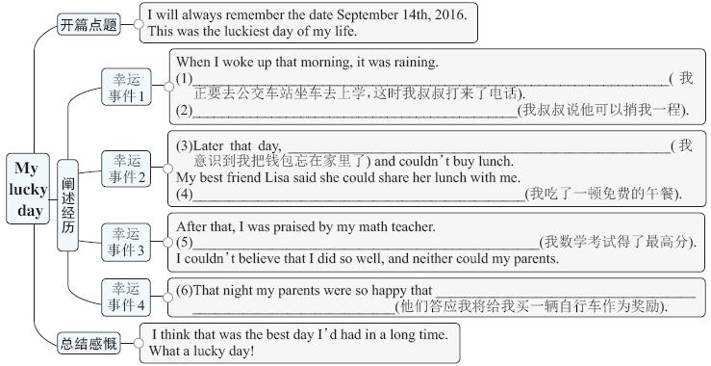

**3. 巧衔接**

在连句成篇时，前后句之间有因果关系，可以用because或so来连接。

此外，在阐述经历时，本文使用了表示时间顺序的表达 (如When I woke up that morning ..., Later that day ..., After that ... 和That night ...) 将几件幸运的事情串联起来，这样做使得上下文之间联系更紧密，文章的脉络更清晰。

**4. 成篇章**

**My lucky day**

_____________________________________________________________________

**2. 谋布局、写句子**

(1) I was about to go to the bus station to take the bus to school when my uncle called me up

(2) My uncle said (that) he could give me a lift in his car

(3) I realized (that) I had left my wallet at home

(4) I had / ate a free lunch

(5) I got the highest score in the math exam

(6) they promised me that they would buy a bike for me as a prize

**4. 成篇章**

**My lucky day**

I will always remember the date September 14th, 2016. This was the luckiest day of my life.

**When I woke up that morning**, it was raining. I was about to go to the bus station to take the bus to school when my uncle called me up. He said he could give me a lift. **Later that day**, I realized I had left my wallet at home and couldn't buy lunch. My best friend Lisa said she could share her lunch with me, so I had a free lunch. **After that**, I was praised by my math teacher **because**I got the highest score in the math exam. I couldn't believe that I did so well, and neither could my parents. **That night** they were so happy that they promised me that they would buy a bike for me as a prize.

I think that was the best day I'd had in a long time. What a lucky day!